

Muhammad Huzaifa Khan

HTML 3

Assignment # 2
JAVASCRIPT

- Declare a variable called username.
Code:
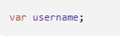
Output:

- Declare a variable called myName & assign to it a string that represents your Full Name.
Code:
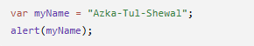
Output:
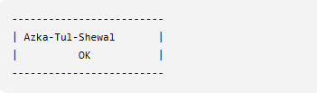

- Write script to

  - Declare a JS variable, titled message.
  - Assign “Hello World” to variable message
  - Display the message in alert box.
Code:

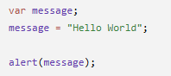
Output:
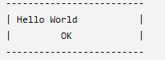
- Write a script to save student’s bio data in JS variables and show the data in alert boxes.
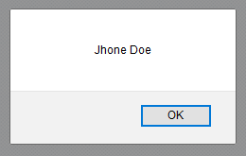
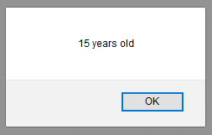
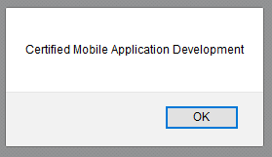

Code:

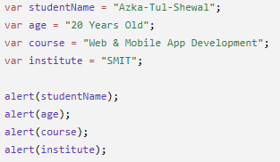
Output:
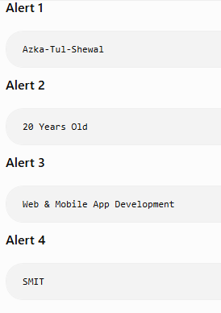


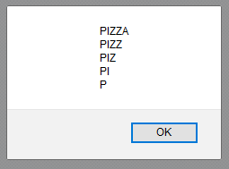
- Write a script to display the following alert using one JS variable:
Code:
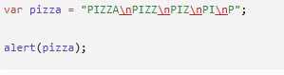

Output:
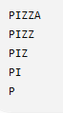
- Declare a variable called email and assign to it a string that represents your Email Address(e.g. example@example.com). Show the blow mentioned message in an alert box.(Hint: use string concatenation)

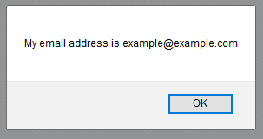
Code:
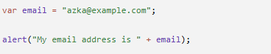
Output:
- Declare a variable called book & give it the value “A
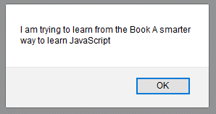
smarter way to learn JavaScript”. Display the following message in an alert box:

Code:

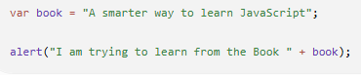

Output:
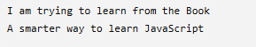


- Write a script to display this in browser through JS

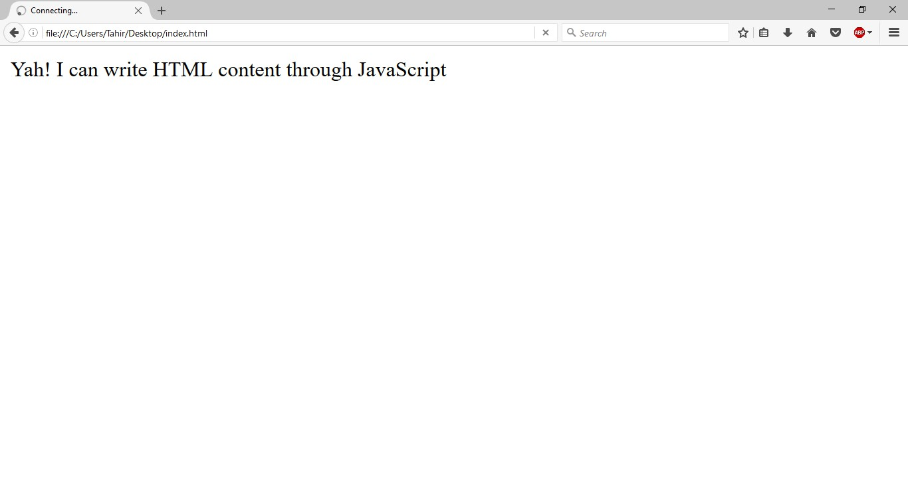
Code:

Output:
- Store following string in a variable and show in alert and browser through JS
“▬▬▬▬▬▬▬▬▬ஜ۩۞۩ஜ▬▬▬▬▬▬▬▬▬”
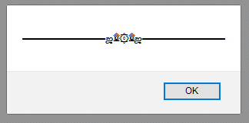

Code:

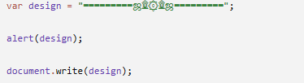

Output:

